Psychology and Aging

© 2025 American Psychological Association
ISSN: 0882-7974

2025, Vol. 40, No. 8, 833–847
https://doi.org/10.1037/pag0000925

Performance in the Iowa Gambling Task in Healthy Aging and Mild Cognitive Impairment

Jeffrey C. Zemla1 and Hasker P. Davis2 1 Department of Psychology, Syracuse University
- Department of Psychology, University of Colorado at Colorado Springs

The Iowa Gambling Task is a common tool for assessing complex decision making in healthy adults and clinical populations. Previous work has found that performance varies among younger adults, cognitively healthy older adults, and individuals with mild cognitive impairment (MCI), a syndrome often precedes
dementia. However, performance on the task depends on many factors, including risk preference, sensitivity to gains and losses, and memory for past outcomes, which makes it difﬁcult to understand what causes these
differences. Here, we ﬁt a computational cognitive model to the data which allows us to attribute differences in behavior to speciﬁc cognitive mechanisms. Experiment 1 (N = 90) compares cognitively healthy older adults to those with MCI, while Experiment 2 (N = 1,645) compares healthy adults of all ages. We ﬁnd that healthy older adults and those with MCI exhibit different proﬁles in the task. Healthy aging is associated with a larger learning rates (we attribute to a recency bias), use of a perseverative strategy, and increased sensitivity to gains over losses. Individuals with MCI learned at a slower rate, but showed no qualitative differences in task strategy. The results have implications for understanding why decision making is impaired in the earliest clinical phases of cognitive decline.

Public Signiﬁcance Statement
This research ﬁnds differences in decision making between healthy aging and clinical impairments to aging (mild cognitive impairment). The ﬁndings are relevant to researchers interested in the mechanisms that underlie impairments in decision making.

Keywords: mild cognitive impairment, aging, decision making, risk, computational modeling
This document is copyrighted by the American Psychological Association or one of its allied publishers.
This article is intended solely for the personal use of the individual user and is not to be disseminated broadly.
All rights, including for text and data mining, AI training, and similar technologies, are reserved.

Older adults frequently choose among options with uncertain  outcomes, and these decisions can have a crucial impact on well-  being. For example, deciding where to invest money among many options with uncertain outcomes can affect whether one is prepared for retirement or unexpected expenses. Though older adults typi- cally have more experience making these sorts of decisions than younger adults, some research has found that older adults are more risk seeking (Mata et al., 2011).  Learning to make good decisions can be further complicated by mild cognitive impairment (MCI), a clinical syndrome of declines in cognition that often precedes a diagnosis of dementia and affects a ﬁfth of adults over the age of 60 (Petersen, 2016). MCI can have a signiﬁcant impact on a person’s daily life, but little research has focused on why decision making is impaired in those with MCI. One reason for this is that the most prevalent symptom of MCI is a | decline in memory (Petersen et al., 1999). Popular cognitive screeners such as the Montreal Cognitive Assessment (Nasreddine et al., 2005) evaluate many different domains of cognition (e.g., memory, lan- guage, executive functioning), but do not include explicit decision- making tasks. When decision making is studied in MCI, it is often in applied contexts, such as decisions about medical treatment or ﬁnancial reasoning (Martin et al., 2019; Okonkwo et al., 2007). In contrast, cognitive psychology has traditionally characterized decision making through more abstract tasks such as intertemporal choice and lottery preferences. Little research has explored whether those with MCI show declines in laboratory tasks, though some work has found that those with MCI are less normative decision makers than cog- nitively healthy older adults. For example, individuals with MCI may be more susceptible to framing effects (Zamarian et al., 2010) and rely more on intuitive than analytical thinking (Zemla, 2025).
This article was published Online First August 11, 2025. | Jeffrey C. Zemla played a lead role in conceptualization, formal analysis,
Hannes Zacher served as action editor. | investigation, methodology, visualization, writing–original draft, and writing–
Jeffrey C. Zemla https://orcid.org/0000-0001-7334-4961 | review and editing and an equal role in data curation. Hasker P. Davis played a
Raw data, behavioral analyses, model code, payout tables, and additional | supporting role in methodology and writing–review and editing and an equal
ﬁgures are available at https://osf.io/9ny2x/. A portion of this work was | role in data curation.
presented as a poster at the 44th Annual Conference of the Cognitive Science | Correspondence concerning this article should be addressed to Jeffrey
Society. The authors thank Nate Haines for help with using hBayesDM and | - Zemla, Department of Psychology, Syracuse University, 442 Marley
model diagnostics. They also thank Joe Austerweil, Mike Kalish, David | Education Center, Syracuse, NY 13210, United States. Email: jczemla@
Kellen, and Eneida Weinman for their feedback. | syr.edu

833

834
This document is copyrighted by the American Psychological Association or one of its allied publishers.
This article is intended solely for the personal use of the individual user and is not to be disseminated broadly.
All rights, including for text and data mining, AI training, and similar technologies, are reserved.

ZEMLA AND DAVIS

One laboratory task that is widely used to assess complex decision making is the Iowa Gambling Task (IGT; Bechara et al., 1994, 2000). In this task, participants repeatedly select among four decks of cards and receive a variable reward with each selection. Participants try to maximize their earnings by learning which decks have the best payouts. Performance depends on many factors such as risk preference, sensitivity to gains and losses, and memory for past
outcomes. Several computational models of the task have been developed (Busemeyer & Stout, 2002; Haines et al., 2018; Ligneul, 2019; Worthy, Pang, & Byrne, 2013), which have been used to explain differences between typical and impaired decision making in clinical populations (Ahn et al., 2016; Busemeyer & Stout, 2002; Yechiam et al., 2005).
Healthy older adults typically show only modest performance differences on the task compared to younger adults (Beitz et al., 2014; Denburg et al., 2005; Fein et al., 2007) or occasionally no signiﬁcant difference (Isella et al., 2008; Wood et al., 2005). Computational models have revealed that while behavioral differ- ences between older and younger adults may be small, older adults may rely on different cognitive and behavioral strategies to complete the task (Beitz et al., 2014; Wood et al., 2005). Few articles have explored whether participants with MCI or dementia are impaired at the task. Zamarian et al. (2011) found that individuals with MCI do poorly at the task and do not learn to choose from the better decks over time, while Sinz et al. (2008) found nearly identical results for individuals with Alzheimer’s disease. Similarly, Jacus et al. (2018) and Bayard et al. (2015) also found that those with MCI or Alzheimer’s disease perform worse than healthy adults, though no differences were detected between individuals with MCI and those with Alzheimer’s disease. Prior work has not used computational models to understand behavior in those with MCI or Alzheimer’s
disease. These differences expose a gap in our understanding: What accounts for performance differences in the IGT in the earliest phases of cognitive decline? As an early harbinger of dementia, MCI presents a test case to examine how behavior transitions from healthy to impaired decision making.
Here, we present data and model ﬁts from two experiments. In the ﬁrst experiment, we ﬁnd that cognitively healthy older adults perform signiﬁcantly better in the IGT than those with MCI. This study is the ﬁrst, to our knowledge, to conduct a model-based analysis among those with MCI, helping to identify the source of impairments in the task. Speciﬁcally, we ﬁnd lower learning rates in those with MCI compared to cognitively healthy adults. We interpret these parameters as reﬂecting learning and memory pro-
cesses, while we do not ﬁnd differences in parameters reﬂecting task
strategy. Though a small number of prior studies have observed behavioral differences in the IGT in those with MCI (Bayard et al., 2015; Jacus et al., 2018; Zamarian et al., 2011), behavioral analyses alone are insufﬁcient to make claims about cognitive mechanisms given the interactive nature of the task (confounding many cognitive
processes). We also provide the ﬁrst publicly available IGT data set among those with MCI (see additional online material at https://osf
.io/9ny2x/).
In the second experiment, we provide context for these ﬁndings by examining differences across the lifespan of cognitively healthy
adults. Using a large cross-sectional data set of healthy adults (ages 18–91), we ﬁnd that performance is stable until around age 60 and shows more pronounced differences after that. This is attributed to both qualitative differences in task strategy and to differential

sensitivity to gains and losses. While some prior work has conducted model-based analyses in aging populations, our analysis allows for a direct comparison to Experiment 1 as they employ the same model.
Together, our results suggest that both healthy older adults and those with MCI differ from younger adults on the task, but that the deﬁcits in healthy aging are distinct from those in MCI and attributable to different cognitive mechanisms.

Overview and Models of the Iowa Gambling Task

The IGT is a multiarmed bandit task where participants select from one of four decks of cards and incur a gain and/or loss with each selection. Two of the decks have a negative expected value
(“bad” decks) while the other two decks have a positive expected value (“good” decks). Participants have 100 trials to maximize their
earnings, which can be done by learning which decks have higher
payouts. Performance on the task is typically assessed behaviorally, for example, by examining whether the proportion of selections from good decks increases over time. However behavioral measures alone are not sufﬁcient to describe the cognitive mechanisms by which participants learn or behave. This is in part because different task strategies can result in equivalent behavior (e.g., similar rates of selecting from good decks; Wood et al., 2005).
As a result, there has been much interest in using computational models of the IGT to infer why behavior differs between individuals or groups. In other words, modeling allows one to attribute dif- ferences in behavior to differences in cognitive mechanisms. Models of the IGT may include parameters that map to psycho- logically relevant properties of decision making, such as how people value gains relative to losses (i.e., a utility function) and how they update their beliefs in response to positive and negative feedback
(i.e., a learning rates). Estimates of these parameters can help explain why groups may display similar behavior in aggregate despite differences in the cognitive mechanisms and strategies used to perform the task (Wood et al., 2005). Reinforcement learning models provide a natural way to model behavior in the IGT, and many variants have been proposed. Each model assumes that in- dividuals track the value of each deck over time, but the mechanisms for updating the value of each deck differ across models. For
example, Steingroever et al. (2013b) implemented a utility function for the value of gains and losses while some models do not include a utility function (Busemeyer & Stout, 2002). Other models include a mix of behavioral strategies: Worthy, Pang, and Byrne (2013) incorporated a perseverative component that emulates a “win-stay- lose-shift” strategy, and Ligneul (2019) incorporated a sequential exploration strategy. Detailed comparisons of IGT models are presented elsewhere (Haines et al., 2018; Steingroever et al., 2013a).
Here, the data is ﬁt to the Outcome-Representation Learning
(ORL) model (Haines et al., 2018). This model was chosen because the literature suggests that it provides a good ﬁt to behavioral data and allows adequate parameter recovery, and because the param- eters of the model are relevant to psychological theories of older and cognitively impaired adults. Another attractive feature of the model is that it incorporates many mechanisms seen in previous models while allowing for ﬂexible parameterization over these mechanisms. For example, it includes a perseverative component like that in
Worthy, Pang, and Byrne (2013) and an expected value com- ponent like that of Busemeyer and Stout (2002). However, under certain parameterizations these components can have no impact

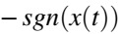
PERFORMANCE IN THE IOWA GAMBLING TASK 835
This document is copyrighted by the American Psychological Association or one of its allied publishers.
This article is intended solely for the personal use of the individual user and is not to be disseminated broadly.
All rights, including for text and data mining, AI training, and similar technologies, are reserved.
EFjðtÞ + Arew · ðsgnðxðtÞÞ − EFjðtÞÞ, if xðtÞ ≥ 0
EFj′ðt + 1Þ
8
′
pun
′
= : (3)
− sgn3ðxðtÞÞ − EF ðtÞ
j′ rew j′
Pr½Dðt + 1Þ = j = P e : (6)
Vkðt+1Þ
EVjðtÞ + Apun · ðxðtÞ − EVjðtÞÞ, if xðtÞ < 0
8
1
>
>
< 1 + K, if DðtÞ = j
PSjðt + 1Þ = , (4)
>
>
: PSjðtÞ, if DðtÞ ≠ j
j
j

on behavior and the model is reduced (e.g., the model subsumes an expected value model while allowing for additional me- chanisms to inﬂuence behavior).
A summary of the model is provided here for convenience (see Haines et al., 2018, for additional information). In the ORL model, the expected value of a deck is updated after each selection from that deck using the δ rule. Separate learning rate parameters are used for gains and losses:
(
EVjðtÞ + Arew · ðxðtÞ − EVjðtÞÞ, if xðtÞ ≥ 0
EVjðt + 1Þ = , (1)

EVj(t) indicates the expected value of deck j at trial t, Arew and Apun are the learning rates for net gains and losses (respectively), and x(t) represents the net gain or loss from the participant’s selection on trial t. The optimal learning rates depend in part on the volatility of the environment (Behrens et al., 2007), that is, the variance in gains and
losses. Values of the learning rates close to zero indicate slow updating of prior beliefs after encountering new information, while values close to one indicate a strong bias toward recent outcomes.
The relative weight given to Arew and Apun reﬂects sensitivity to gains and losses. Though not a separate free parameter, we calculate Adiff = Arew − Apun to explore differences in this sensitivity. Larger values of Adiff indicate a greater inﬂuence of wins on the deck’s
value, while smaller values indicate a greater inﬂuence of losses on the deck’s value.
The ORL model augments a traditional expected value model by separately tracking the expected frequency of wins from each deck:

EFjðt + 1Þ
(
= , (2)
EFjðtÞ + Apun · ðsgnðxðtÞÞ − EFjðtÞÞ, if xðtÞ < 0

EFj(t) denotes the expected frequency of winning from deck j at trial t, and sgn(x(t)) indicates the sign (but not the magnitude) of the net outcome (1, 0, or −1). This component of the model represents a qualitatively different strategy to tracking expected value. Attending to the expected frequency could be an effective task strategy because it is simpler than tracking expected value, but this strategy can be detrimental if a deck has frequent losses punc- tuated by occasional large gains, or vice versa—which is indeed the case for some decks in the IGT. The ORL model also includes a ﬁctive error signal that is used to update each of the decks that were not chosen ( j′):

EF ðtÞ + A · − EF ðtÞ , if xðtÞ ≥ 0
EF ðtÞ + A · , if xðtÞ < 0
This ﬁctive learning signal allows the ORL model to account for rapid reversal learning common in the IGT. Speciﬁcally, the task is designed so that Deck B emerges as a frequent choice for healthy participants early in the task because the ﬁrst eight cards from this deck are net gains. However, on the ninth card, a large loss is incurred that more than wipes out all previous gains from that deck.

Healthy participants rapidly update their beliefs to reﬂect that Deck B is no longer a good choice, and models without a ﬁctive error signal have some difﬁculty mimicking this rapid reversal learning
(Haines et al., 2018).
Finally, the model also includes a perseverative component that increases the probability of selecting the same deck multiple times in a row. This component can help capture the behavior of participants who engage in a simple “win-stay, lose-switch” strategy:

1 + K

PSj(t) indicates the perseveration value of deck j on trial t. K is a parameter typically estimated from the data, but for both experi- ments reported below K is ﬁxed to one.1 D(t) indicates the deck selected on trial t.
After each trial, the value of the decks are updated as a weighted combination of the expected value, expected frequency, and per- severation components:

- jðt + 1Þ = EVjðt + 1Þ + βF · EFjðt + 1Þ + βP · PSjðt + 1Þ, (5)

- j(t) indicates the overall value of deck j on trial t. βF and βP are weights on the expected frequency and perseveration components,
respectively, and indicate the relative emphasis a participant places on each of these strategies. High positive values of βF indicate a preference for selecting from decks with high win frequency (regardless of magnitude). Values of βP greater than zero indicate a tendency to repeatedly select from the same deck, while values less than zero indicate a tendency to switch decks. On any trial, the predicted probability of selecting from deck j is proportional to the value of that deck, using an exponentiated Luce choice rule (i.e.,
softmax):

eVjðt+1Þ
=1

The parameters of the ORL model may correspond to psycho- logically relevant mechanisms that vary with age, including memory
(Arew and Apun), positivity bias (Adiff), and differences in task strategies that vary in computational complexity (βF and βP).
However, these interpretations are somewhat speculative, since converging evidence from independent tasks remains limited. We predicted that Arew and Apun would be larger for older adults than younger adults, and larger for those with MCI than cognitively healthy older adults. Larger values indicate a greater inﬂuence of recent outcomes on deck value, and values close to one have been interpreted as rapid forgetting of past trial outcomes (Steingroever et
al., 2013a, 2013b). These predictions were made because working memory declines with healthy aging and in MCI (Kirova et al., 2015). We also predicted that older adults would show a larger bias toward gains than losses (larger Adiff) compared to younger adults, but that individuals with MCI would show lower Adiff than healthy

- In Experiment 1, a strong, systematic trade-off between βP and K was
observed, which makes identiﬁability of these two parameters infeasible. In the model analyses presented here, the value of K was ﬁxed to one in order to obtain more reliable estimates of βP.

836
This document is copyrighted by the American Psychological Association or one of its allied publishers.
This article is intended solely for the personal use of the individual user and is not to be disseminated broadly.
All rights, including for text and data mining, AI training, and similar technologies, are reserved.

ZEMLA AND DAVIS
2

older adults. These predictions are motivated by evidence for increased attention toward and memory for positive stimuli in older adults compared to younger adults (i.e., the positivity effect; Mather
& Carstensen, 2005), but a diminished positivity effect in those with Alzheimer’s disease (Kalenzaga et al., 2016). Apart from memory and attention, there are also age-related differences in sensitivity to
losses. For example, older adults tend to be more loss averse than younger adults (Mrkva et al., 2020). Horn (2024) noted that older adults experience a greater ratio of losses than gains in life, and may compensate for this by placing a higher weight on negative than positive information to avoid losses, and in some domains older adults have demonstrated a negativity bias in learning (Frank &
Kong, 2008). This work would suggest an alternative hypothesis that healthy older adults may show smaller values for Adiff than younger adults.
Finally, we predicted that older adults would show larger values for βF and βP compared to younger adults, and that those with MCI would show larger values compared to cognitively healthy adults. These parameters have been described as reﬂecting use of cognitive strategies other than maximizing long-term expected value (Haines et al., 2018). These predictions are motivated by prior work which has found older adults, relative to younger adults, engage in cog- nitively simpler task strategies that require less information (Mata et
al., 2007, 2010). We expected this to be accentuated with MCI. In
addition, older adults and those with MCI are known to have increased rates of perseveration (Corbo et al., 2024; Lemaire & Leclère, 2014).

Experiment 1 Transparency and Openness

The study was approved by the Institution Review Board at the University of Wisconsin–Madison, Protocol 2020-0408 titled
“Individual Differences in Explanation.” All data and analysis code are available in the additional online material (https://osf.io/9ny2x/). All eligible participants who responded to the recruitment ad were provided a link to participate, and all available data were used for data analysis except as noted. The study was not preregistered. Information about the race and ethnicity of participants has been lost due to a data linkage error.

Participants

One hundred ﬁve participants were recruited for an online study from the Alzheimer’s Prevention Registry (https://www.endalznow
.org; Langbaum et al., 2020). Data were collected in 2020, and participants were based in the United States. The recruitment ad targeted older adults who had previously reported a diagnosis of
MCI, as well as healthy older adults who had no history of cognitive
impairment. During the study, participants self-reported any cog- nitive impairment diagnoses they had received from a list of six diagnoses (MCI, Lewy Body Dementia, Alzheimer’s disease, Huntington’s disease, Parkinson’s disease, and medication- induced delirium), plus an open-ended response to indicate any additional cognitive impairments. Twelve participants were excluded for having other diagnoses (e.g., Alzheimer’s disease) or comorbidities in addition to MCI. Three more participants were excluded as outliers for repetitive behavior (selecting the same

deck in the IGT task more than 75 times). Of the remaining 90
participants, 45 reported having received a diagnosis of MCI (ages 56–85, Mage 67.0) and 45 were cognitively healthy (ages 56–77, Mage 67.1, one age unknown). Additional demographics are provided in Table 1.

Procedure

Participants completed several tasks as part of a separate research project (Zemla, 2025). These tasks included reading short vignettes and explaining a “surprising event,” semantic and letter ﬂuency tasks (e.g., Troyer et al., 1997), the cognitive reﬂection test
(Frederick, 2005), and a subjective cognitive decline scale (modiﬁed from Miebach et al., 2019). Afterward, participants were redirected to a new page with the IGT. An open-source implementation of the task from Margevicius (2015) was used.
In the IGT, participants saw four decks of cards labeled A, B, C, and D (Figure 1). Participants completed 100 trials. On each
trial, participants selected a card from any of the decks and either won or lost money. Participants began with $2,000 and were told to “win as much money as possible” and that “you are free to switch from one deck to the other at any time, and as often as you wish.” Feedback after each selection indicated the amount won, lost, net gain or loss, and their total cash pile remaining
(Figure 1). Decks A and B had a negative expected value (the
“bad” decks), while Decks C and D had a positive expected value (the “good” decks). The full payout table, indicating the win and loss for every draw, is available in the additional online material
(https://osf.io/9ny2x/). A summary of the deck properties is shown in Table 2.

Behavioral Results

As a cursory check, we compared performance between MCI and cognitively healthy participants on ancillary tasks. Individuals with MCI scored lower than cognitively healthy adults on the letter ﬂuency task, semantic ﬂuency task, and the cognitive reﬂection test, and scored higher than healthy participants on the subjective cognitive decline scale (all p < .06 controlling for age). See additional online material (https://osf.io/9ny2x/) for a summary of these results or Zemla (2025) for more extensive analyses.
Overall, healthy participants did not choose signiﬁcantly more from good decks than those with MCI, Mhealthy = 53.5, MMCI =
50.1, t(86.3) = 1.23, p = .22, Cohen’s d = 0.26. Both groups lost money overall, however those with MCI lost signiﬁcantly more money (in dollars), Mhealthy = −112, MMCI = −459, t(87.9) = 2.3, p = .02, Cohen’s d = 0.49. The mean response time per trial was 2,286 ms, and there was no signiﬁcant difference in response times between groups, Mhealthy = 2,009 ms, MMCI = 2,563 ms, t(48.6) = 1.12, p = .27, Cohen’s d = 0.24. Approximately, 80% of trials resulted in a net gain, 19% in a net loss, and 1% in no net
change. This asymmetric distribution partially reﬂects learning by the participants, but also reﬂects the payout table (see additional

- This cut-off was chosen to identify those who did not engage in the task as directed. The most selected deck of each participant was chosen an average of 42.5 times (SD = 13.9), so a cut-off of 75 reﬂects slightly more than 2 standard deviations from the mean. These participants may have
“clicked through” the experiment rather than engage with the task.

PERFORMANCE IN THE IOWA GAMBLING TASK 837
This document is copyrighted by the American Psychological Association or one of its allied publishers.
This article is intended solely for the personal use of the individual user and is not to be disseminated broadly.
All rights, including for text and data mining, AI training, and similar technologies, are reserved.

Table 1
Demographics for Experiment 1

Demographic

Cognitively healthy N (%)

MCI N (%)

Total N (%)

Number of participants | 45 (50) | 45 (50) | 90 (100)
Age
56–60 | 5 (11.1) | 8 (17.8) | 13 (14.4)
61–70 | 22 (48.9) | 20 (44.4) | 42 (47.8)
71–80 | 17 (37.8) | 14 (31.1) | 31 (34.4)
81–85 | 0 (0.0) | 3 (6.7) | 3 (3.3)
Unknown | 1 (2.2) | 0 (0.0) | 1 (1.1)
Gender
Female | 26 (57.8) | 33 (73.3) | 59 (65.6)
Male | 19 (42.2) | 12 (26.7) | 31 (34.4)
Education
High school degree | 1 (2.2) | 2 (4.4) | 3 (3.3)
Some college | 8 (17.8) | 15 (33.3) | 23 (25.6)
College graduate | 19 (42.2) | 15 (33.3) | 34 (37.8)
Postgraduate | 17 (37.8) | 12 (26.7) | 29 (43.3)
Unknown | 0 (0.0) | 1 (2.2) | 1 (1.1)

Note. MCI = mild cognitive impairment.

online material at https://osf.io/9ny2x/) in which net gains are more common.
The data were ﬁt to a mixed-effects logistic regression model, with deck choice (good or bad) as the dependent variable and trial
number, diagnosis (healthy or MCI), and their interaction as pre-
dictors. Age was included as an additional covariate, and a random intercept was included for each participant. All variables were centered to ensure the model would converge. Selections from good decks increased as the task progressed (i.e., with increased trial number), z = 8.57, p < .0001, OR = 1.21; however, this also interacted with participant diagnosis, z = −4.10, p < .0001, OR =
.91. Cognitively healthy participants showed larger improve- ments over the course of the experiment relative to those with MCI

(Figure 2). Main effects of age and diagnosis were not signiﬁ- cantly associated with deck selection (both p > .15).
Cognitively healthy older adults showed a pattern of behavior that is typical and expected in the IGT (Figure 3). Selections from Decks A and B decrease over time, while selections from Decks C and D
increase. These patterns were conﬁrmed with four logistic regres- sion models (one for each deck) with trial number as a predictor (all p < .001) and participant as a random intercept. Early in the task, Deck B is the most selected deck. This pattern is common in the
IGT, as the ﬁrst eight cards from this deck are gains. It is not until the ninth card from Deck B that participants incur a large loss. Participants with MCI showed less typical results (Figure 3). While selections from Deck A decrease (p < .0001), there is a slight

Figure 1
A Screenshot of the Iowa Gambling Task as Shown to Participants in Experiment 1

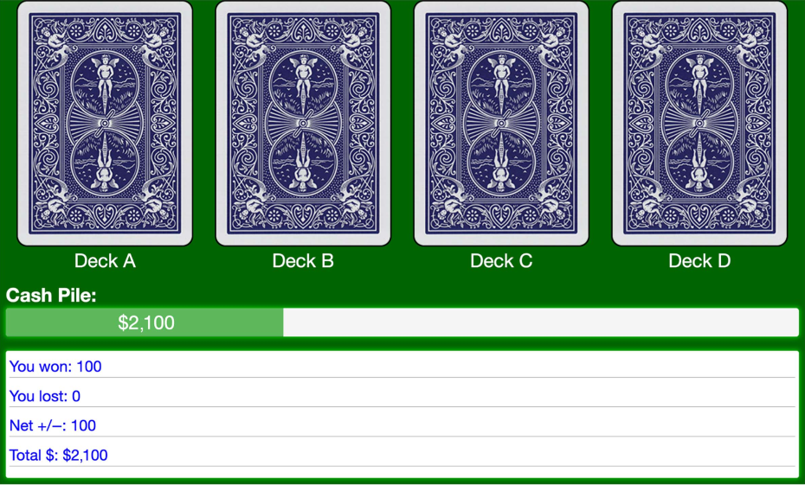

Note. The screenshot is from the open-source implementation of the Iowa Gambling Task from Margevicius (2015), which is based on the task from Bechara et al. (1994). See the online article for the color version of this ﬁgure.

838

ZEMLA AND DAVIS
Deck characteristic
Deck A Deck B Deck C Deck D

Table 2
Summary of Deck Statistics in Experiment 1

Expected value | −25 | −25 | 25 | 25
Expected % of wins | 50% | 90% | 62.5% | 90%
Expected % of losses | 50% | 10% | 12.5% | 10%
Expected % of break-even trials | 0% | 0% | 25% | 0%

Note. Percentages refer to the percentage of cards in the deck (regardless of the win or loss magnitude).

increase in selections over time from Decks B (p = .08), and a similarly marginal increase in selections from Decks C (p = .07) and D (p = .07).

Model Results

The ORL model was ﬁt using hBayesDM 1.1.1 (Ahn et al., 2017), which implements a hierarchical Bayesian model in Stan (Carpenter et al., 2017) to estimate both group-level and participant-level posterior distributions simultaneously for each of the four param- eters in the model (Arew, Apun, βF, and βP). The hierarchical aspect of the model allows for heterogeneity within the group. In other words, we do not assume that all participants complete the task in the same
way. It is possible, for example, that some participants rely on a perseverative strategy and have a high value for βP, while other participants from the same group have a very low value for this parameter and do not perseverate. Below, we focus our discussion on the group-level parameters to understand whether there are any systematic differences between groups.
All of the default settings in hBayesDM were used for parameter estimation (four Markov chains, 4,000 samples per chain including 1,000 burn-in samples, no thinning), except that the code was

Figure 2
Selections From Good and Bad Decks by Group

modiﬁed to constrain K = 1 (see Footnote 1). Separate models were ﬁt for the cognitively healthy and MCI groups. Trace plots of the resultant Markov chains were inspected visually for convergence (see additional online material at https://osf.io/9ny2x/), with all R̂ in the range 1.0001–1.001. Model ﬁt was assessed by plotting the one- step-ahead posterior predictions and visually comparing these to the behavioral data (shown in the additional online material at https://
osf.io/9ny2x/).
Posterior parameter estimates for each group are shown in Figure 4. Ninety-ﬁve percent high density interval regions (HDI; Hyndman, 1996) were used to examine whether the differences in group-level parameters were credible. Cognitively healthy older adults had larger values for both reward learning rates, Arew (Mhealthy = 0.695, MMCI = 0.427, 95% HDI [0.102, 0.433], Cohen’s d = 1.07) and Apun (Mhealthy = 0.166, MMCI = 0.115, 95% HDI [0.019, 0.087], Cohen’s d = 1.00). No credible differences were observed for βF
(Mhealthy = 0.817, MMCI = 0.921, 95% HDI [−0.676, 0.488], Cohen’s d = 0.08) or βP (Mhealthy = 1.90, MMCI = .861, 95% HDI [−0.102, 2.121], Cohen’s d = 0.38).
We also computed the difference in learning rates (i.e., Adiff = Arew − Apun) for each group to measure sensitivity to gains relative to losses. While both groups had a credibly higher learning rate for gains relative to losses (i.e., Adiff > 0), the difference was larger for cognitively healthy older adults relative to those with MCI (Mhealthy = 0.529, MMCI = 0.313, 95% HDI [0.054, 0.378], Cohen’s d = 0.91).
As described earlier, ancillary measures were collected as part of a separate research project (animal ﬂuency, letter ﬂuency, cognitive reﬂection test, and subjective cognitive decline scale; Zemla, 2025). We compared performance on these tasks to participant-level parameter values using maximum a posteriori estimates. Four participants were missing data on these tasks. Arew was correlated with animal ﬂuency, r(86) = .23, p = .03, and subjective cognitive

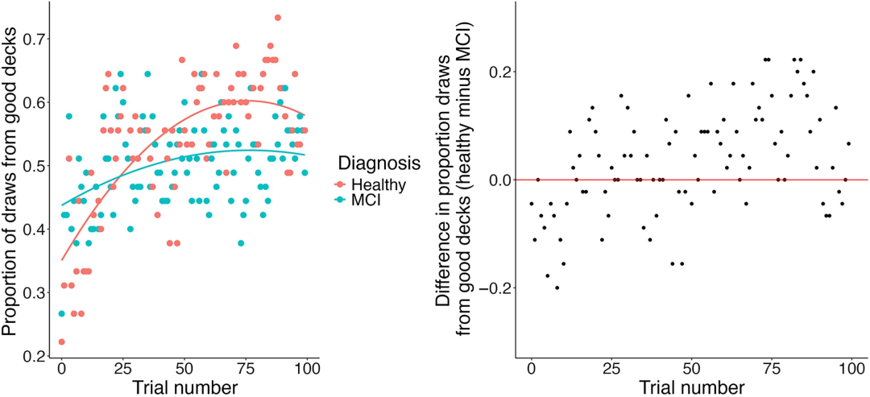
This document is copyrighted by the American Psychological Association or one of its allied publishers.
This article is intended solely for the personal use of the individual user and is not to be disseminated broadly.
All rights, including for text and data mining, AI training, and similar technologies, are reserved.

Note. (Left) The proportion of participants choosing from a good deck is shown for each trial and group. Loess trend lines for each group are shown. (Right) The difference in proportion of good deck choices between the two groups is shown for each trial. Values below zero indicate that the MCI group chose more often from the good
decks, while values above zero indicate the healthy group chose more often from the good decks. MCI = mild cognitive impairment. See the online article for the color version of this ﬁgure.

PERFORMANCE IN THE IOWA GAMBLING TASK 839

Figure 3
The Proportion of Selections From Each Deck on Each Trial

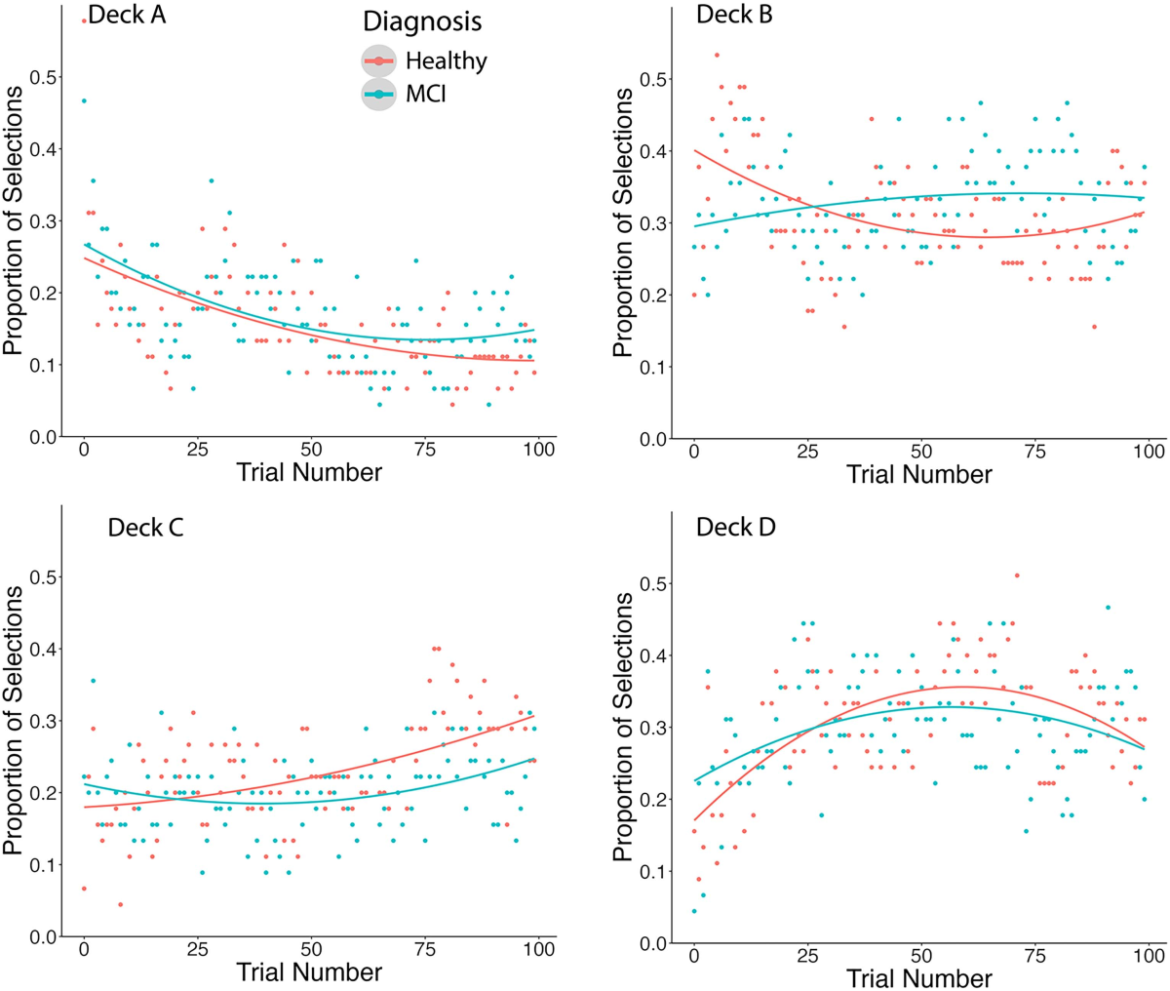
This document is copyrighted by the American Psychological Association or one of its allied publishers.
This article is intended solely for the personal use of the individual user and is not to be disseminated broadly.
All rights, including for text and data mining, AI training, and similar technologies, are reserved.

Note. Loess trend lines are shown for visualization. Red indicates healthy participants and blue indicates MCI. MCI = mild cognitive impairment. See the online article for the color version of this ﬁgure.

decline, r(86) = −.28, p = .009. Apun was correlated with animal ﬂuency, r(86) = .22, p = .044, and subjective cognitive decline, r(86) = −.23, p = .038. Adiff was correlated with animal ﬂuency, r(86) = .21, p = .049, and subjective cognitive decline, r(86) = −.26, p = .014. While these analyses were not planned, they provide some supporting evidence that the learning rate parameters are related to memory processes as we have suggested. All other correlations were not signiﬁcant (all p > .069).

Discussion

Both groups showed evidence of learning by choosing more often from the good decks over time, in contrast to prior work that has found individuals with MCI do not improve at the task over time
(Zamarian et al., 2011). However, cognitively healthy adults showed steeper improvements than those with MCI. The marginal probability of selecting from the good decks did not differ between groups, though those with MCI lost signiﬁcantly more money. Performance did not vary with age after controlling for diagnosis.

While we observed some differences in model parameters, these differences diverged from our predictions. The cognitively healthy group had larger learning rates for both rewards (Arew) and losses
(Apun) compared to those with MCI, indicating more rapid up- dating of a deck’s value in response to gains or losses but also a stronger inﬂuence of recent outcomes on deck selection. No differences in the weights on expected frequency (βF) and per- severation (βP) were observed between groups. This may indicate that despite differences in learning rate, those with MCI do not rely on qualitatively different task strategies than cognitively healthy older adults. Both groups had larger learning rates for gains relative to losses (Adiff greater than zero), indicating that learning is affected more by gains than losses, but healthy par- ticipants had larger values of Adiff than those with MCI.
The results are limited only to older adults, and do not indicate how healthy aging may affect performance relative to younger
adults. We address this in Experiment 2 by using a previously collected data set to test for differences across the lifespan, providing context to help interpret the results. Afterward, we discuss the results from both experiments wholistically.

840

ZEMLA AND DAVIS

Figure 4
Posterior Distributions of Parameters in Experiment 1

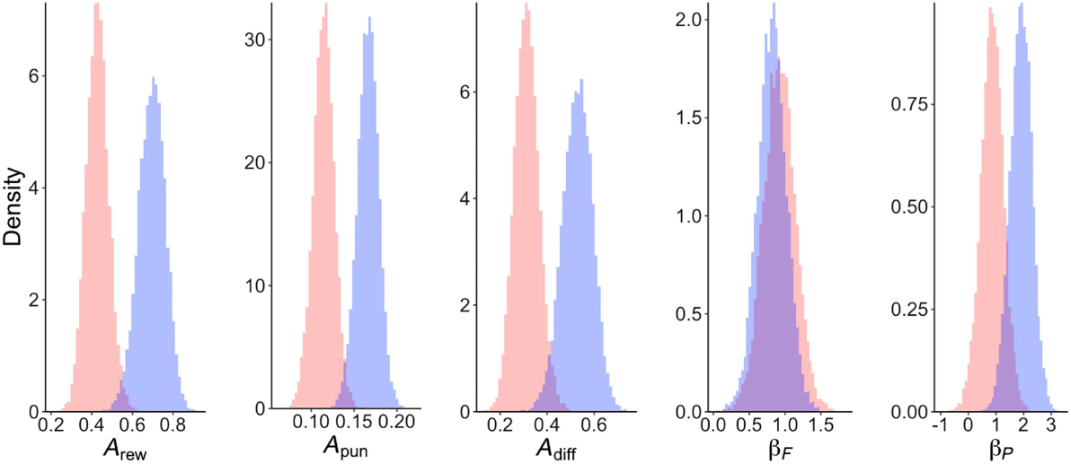

Note. Posterior distributions indicate that cognitively healthy older adults (blue) had larger values of Arew, Apun, and Adiff compared to participants with mild cognitive impairment (red). There were no credible differences in βF or βP. See the online article for the color version of this ﬁgure.
This document is copyrighted by the American Psychological Association or one of its allied publishers.
This article is intended solely for the personal use of the individual user and is not to be disseminated broadly.
All rights, including for text and data mining, AI training, and similar technologies, are reserved.

Experiment 2 Transparency and Openness

The study was approved by the Institution Review Board at the University of Colorado, Colorado Springs, Protocol 12-229 titled
“Cognition Across the Lifespan: 5–95 years of age.” All data and analysis code are available in the additional online material (https://
osf.io/9ny2x/). All available data were used for data analysis. The study was not preregistered. A portion of the data have been pre- viously reported in Beitz et al. (2014) and a very small portion was reported in Wood et al. (2005), though the analyses presented here are novel.

Participants

The data set consists of 1,645 participants who were at least 18 years (M = 35.9, range = 18–91). Ages skewed younger (inter- quartile range 20–50 years; see the additional online material at
https://osf.io/9ny2x/ for a histogram of ages at 1-year increments). Additional demographics are provided in Table 3.

Procedure

The data were collected between 2001 and 2017 from the second author’s lab. Data were collected in Colorado Springs, Colorado, United States. All testings were conducted in person in quiet testing
rooms. Participants included students receiving course credit and older adults recruited from the university gerontology center for 10 dollars per hour. Participants were tested individually lasting approximately an hour. Participants reported no history of neuro- logical disease, head trauma, learning disability, psychiatric illness, or drug use that they thought might affect their cognition. Participants were told that they would be given several tests of general cognitive functioning, including memory and reasoning tests.
Participants completed the IGT, but a different implementation than Experiment 1 was used (Bechara, 2007) which uses a different

payout table (found in the additional online material at https://osf.io/
9ny2x/). A summary of the deck properties is shown in Table 4. The general patterns remain the same: Decks A and B had a negative expected value while Decks C and D had a positive expected value,

Table 3
Demographics for Experiment 2
Demographic | N (%)
Age
18–19 | 376 (22.9)
20–29 | 586 (35.6)
30–39 | 139 (8.4)
40–49 | 132 (8.0)
50–59 | 85 (5.2)
60–69 | 121 (7.4)
70–79 | 146 (8.9)
80–89 | 56 (3.4)
90–91 | 4 (0.2)
Gender
Male | 476 (28.9)
Female | 1,168 (71)
Unknown | 1 (0.1)
Education
- or fewer years | 6 (0.3)
9–12 years | 115 (7.0)
12–16 years | 1,378 (83.8)
More than 16 years | 125 (7.6)
Unknown | 21 (1.3)
Race/ethnicity
White/NonHispanic | 1,115 (67.8)
African American | 55 (3.3)
Hispanic/Latino | 124 (7.5)
East Asian | 31 (1.9)
West Asian | 10 (0.6)
Native American | 6 (0.4)
Paciﬁc Islander | 9 (0.5)
Multiple race/ethnicity | 116 (7.1)
Other | 6 (0.3)
Unknown | 8 (0.5)

PERFORMANCE IN THE IOWA GAMBLING TASK 841
Deck characteristic
Deck A Deck B Deck C Deck D

Table 4
Summary of Deck Statistics in Experiment 2

Expected value | −62.5 | −62.5 | 31.25 | 31.25
Expected % of wins | 26.7% | 90% | 80% | 90%
Expected % of losses | 71.6% | 10% | 16.7% | 10%
Expected % of break-even trials | 1.7% | 0% | 3.3% | 0%

Note. Percentages refer to the percentage of cards in the deck (regardless of the win or loss magnitude).

and each of these pairs of decks differed in their proportion of wins. All data and analysis code are provided in the additional online material (https://osf.io/9ny2x/).

Behavioral Results

Participants selected less from Decks A and B over time while selections from Decks C and D increased (all p < .0001 from logistic

Figure 5
Proportion of Selections From Each Deck on Each Trial

regression). This mirrors the behavior of cognitively healthy older adults in Experiment 1. Proportions of deck selections (collapsed across age) are shown in Figure 5. As in Experiment 1, the dis- tribution of win frequencies was asymmetric: 77% trials results in a net gain, 16% in a net loss, and 1% in no net change.
We expected behavior in the task to differ with age, and that these differences would accelerate with advanced age. This hypothesis was tested with a mixed-effects logistic regression model predicting deck choice (good or bad) from trial number, age, and age-squared (participant was treated as a random intercept). We include the quadratic effect of age based on visual inspection of the data (see Figure 6, left) and prior work (e.g., Fein et al., 2007 also ﬁnd evidence of a quadratic relationship). Fixed effect variables were standardized and mean centered to ensure the model would converge. Participants selected from the good decks more often as the trial number
increased, z = 68.7, p < .0001, OR = 1.45, 95% conﬁdence interval
(CI) [1.44, 1.46]. Age-squared was a signiﬁcant negative predictor of selecting from a good deck, z = 5.02, p < .0001, OR = 0.9, 95% CI [0.86, 0.94], but age (not squared) was not, p = .17, OR = 1.04,

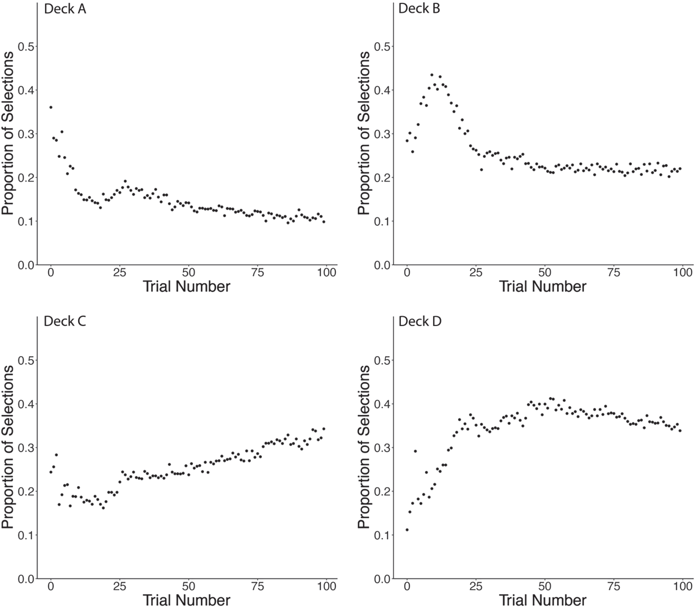
This document is copyrighted by the American Psychological Association or one of its allied publishers.
This article is intended solely for the personal use of the individual user and is not to be disseminated broadly.
All rights, including for text and data mining, AI training, and similar technologies, are reserved.

Note. Participants chose less from Decks A and B (the “bad” decks) and more from Decks C and D (the “good” decks) over
time. Aggregate behavior of participants is shown (collapsed across age).

842
χ2
3 A nested model comparison revealed that a quadratic model provided a

ZEMLA AND DAVIS

Figure 6
Proportion of Selections From Good Decks by Age

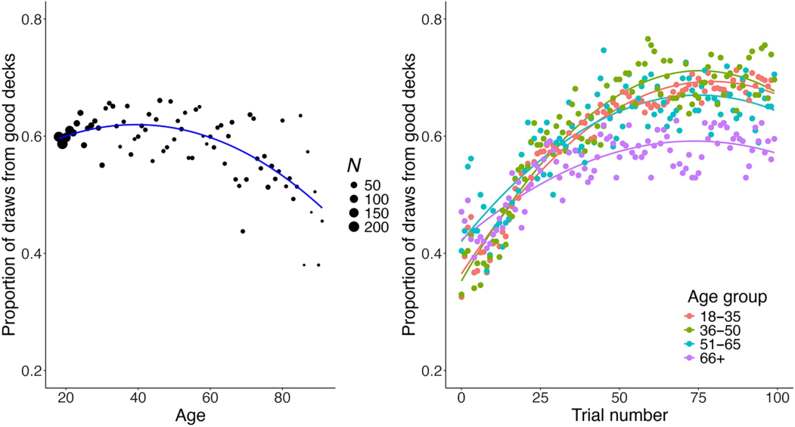

Note. (Left) The marginal proportion of selections from good decks decreased with age. Note that the number of participants per age varies, with larger sample sizes for younger ages, reﬂected here in the size of each data
point. Predictions from the quadratic logistic regression model (excluding the random effect of participant) are shown as a blue trend line. (Right) Participants chose from good decks more over time, but older participants learned to do so at a slower rate than younger adults. Ages are binned, and loess trend lines are shown for visualization. See the online article for the color version of this ﬁgure.
This document is copyrighted by the American Psychological Association or one of its allied publishers.
This article is intended solely for the personal use of the individual user and is not to be disseminated broadly.
All rights, including for text and data mining, AI training, and similar technologies, are reserved.
3
95% CI [0.985, 1.088]. Years of education is also a signiﬁcant

predictor when included as a covariate, z = 2.31, p = .032. Figure 6 shows the proportion of selections from good decks for each age.

Model Results

A model was ﬁt to the data using the same procedure as Experiment 1, except that all participants were treated as a single group (i.e., one hierarchical model for all participants). Trace plots of the resultant Markov chains were inspected visually for con- vergence (see additional online material at https://osf.io/9ny2x/), with all R̂ in the range 1.0005–1.0036. We estimated the effect of age on each model parameter using regression. Based on the plots
(Figure 7), we tested both simple linear regression (e.g., Arew ∼ Age) and a model that includes a quadratic term (e.g., Arew ∼ Age + Age2). In the results below, we report the quadratic model only when Akaike information criterion (AIC) indicates a better ﬁt over the linear model (see additional online material at https://osf.io/9ny2x/ for a full model comparison). Instead of using the maximum likelihood estimate for each participant as the outcome variable, we ﬁt separate regression models for each Markov chain sample, which allowed us to estimate a distribution for each regression slope. Independent and dependent variables were scaled to produce standardized regression coefﬁcients for interpretability. This process resulted in 12,000 estimates for each regression slope. The distribution of estimates for each slope was assessed using a 95% HDI to see whether the coefﬁcient credibly differed from zero.
Arew increased with age (β = .16, 95% HDI [0.13, 0.19]). Apun increased with age (β = .61, 95% HDI [0.47, 0.75]) and then decreased with age-squared (β = −.61, 95% HDI [−0.75, −0.47]). Adiff also increased with age (β = .17, 95% HDI [0.13, 0.20]). βF decreased with age-squared (β = −.2, 95% HDI [−0.39, −0.01]), but

not age. βP increased with age (β = .68, 95% HDI [0.60, 0.77]) and decreased with age-squared (β = −.54, 95% HDI [−0.63, −0.46]). These trends are shown in Figure 7, and parameters are summarized in Table 5. For all parameters, the oldest participants (e.g., 80+) appear to show more pronounced differences in model parameters, but the limited number of participants in this age range precludes a more detailed analysis (only 3.6% of participants were 80+).

General Discussion

In two experiments, we found differences in behavior on the IGT among younger adults, cognitively healthy older adults, and older adults with MCI. Notably, we found that individuals with MCI improved on the task over time, which contrasts with previous work that found no improvement (Zamarian et al., 2011). However, the proportion of selections from good decks increased for cognitively healthy older adults at a faster rate than those older adults with MCI. Individuals with MCI lost signiﬁcantly more money in the task, though the marginal proportion of selections from good decks did not differ between groups. In the second experiment, we found that performance was worse in older adults, though the decrease with age was not linear and was steepest at the most advanced ages in our
sample. The proportion of selections from good decks remained relatively stable from ages 18 to roughly 60 years.
To evaluate differences in strategy and cognition, we ﬁt the data from both experiments to the ORL reinforcement learning model of the task (Haines et al., 2018). A summary of the ﬁndings is presented in Table 6. We predicted that participants would shift toward simpler

better ﬁt to the data than a linear model, (1) = 25.0, p < .0001, AICrestricted = 208,469, AICfull = 208,446.

PERFORMANCE IN THE IOWA GAMBLING TASK 843

 | Mean β age | Mean β age2
Dependent variable | (standardized) | (standardized)

Arew Apun Adiff βF βP
.16a
.608
.166
.076
.679
a
a
a
−.611a

−.204a −.542
a
4

Figure 7
Parameter Values by Age

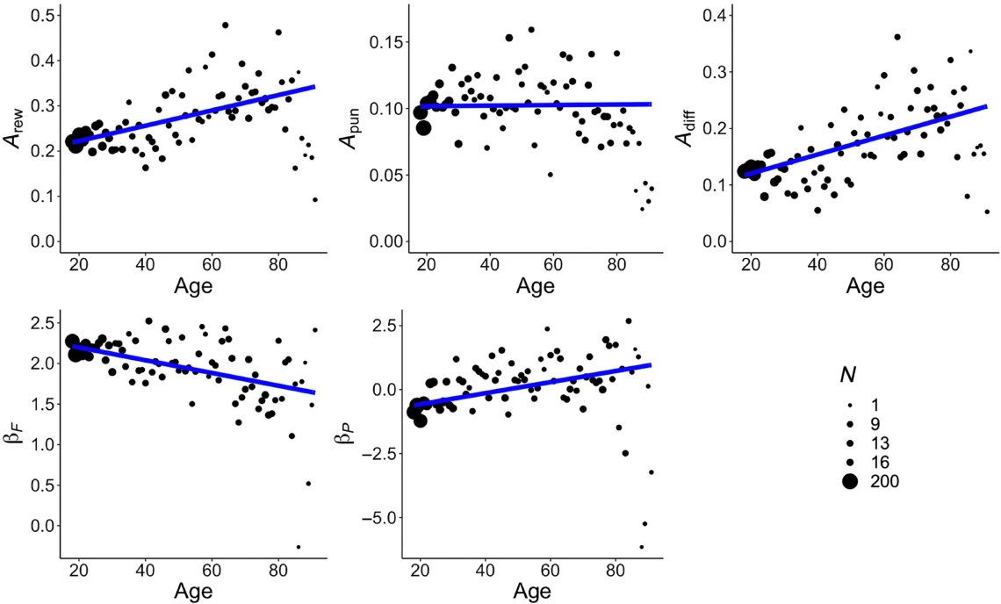

Note. All parameters varied with age or age-squared (or both). Predictions from a simple linear regression model are shown as blue trend lines. The number of participants per age varied, with larger sample sizes for younger ages (reﬂected in the size of each data point). See the online article for the color version of this ﬁgure.
This document is copyrighted by the American Psychological Association or one of its allied publishers.
This article is intended solely for the personal use of the individual user and is not to be disseminated broadly.
All rights, including for text and data mining, AI training, and similar technologies, are reserved.

task strategies with age and MCI, reﬂected in higher values of βP (a perseverative strategy) and βF (a frequency-tracking strategy). This prediction was only partially borne out. Younger adults had negative values of βP, indicating a tendency to switch decks, while older adults had larger and positive values for βP, indicating a tendency to perseverate on the same deck. One interpretation of this is that older adults engaged in a cognitively simpler strategy that leads to per- severative behavior, such as a win-stay-lose-shift strategy (Cassotti et al., 2011; Worthy, Hawthorne, & Otto, 2013), or strategic information sampling (e.g., repeated sampling of a single deck before switching to a different deck). In contrast, younger adults might be engaged in a more exploratory strategy, frequently switching between decks to gather information about all decks early
on. However, it is also possible that perseveration is not strategic but
automatic, for example, reﬂecting diminished inhibition in older
adults. Both cognitively healthy older adults and those with MCI showed evidence of perseveration (positive values of βP), but we

Table 5
Summary of Model Parameter Associations With Age

a A credible result (i.e., high density interval excludes zero). Quadratic terms are reported only when Akaike information criterion indicates a better ﬁt over the linear model.

found no difference between the two groups. This suggests that whether the difference is strategic or automatic, it is likely a con- sequence of healthy aging that does not worsen in MCI. Contrary to
expectations, it was younger adults who had larger values of βF relative to older adults, indicating an emphasis on decks with high win frequency (not necessarily those with high expected value). We found no difference between cognitively healthy older adults and those with MCI for this parameter.
These results hint at the possibility of differences in task strategy between older and younger adults, but not between healthy older adults and those with MCI. Rather, differences in performance between cognitively healthy adults and adults with MCI can be attributed to differences in learning rates and the relative inﬂuence of gains and losses. In Experiment 1, those with MCI had smaller values for both learning rate parameters (Arew and Apun). This was the opposite of what was expected, given that larger learning rates have been associated with rapid forgetting (Steingroever et al., 2013a, 2013b). It also seemingly contrasts with Smart and Krawitz
(2015), who found those individuals with subjective cognitive decline (a preclinical measure that precedes MCI) rely more on recent outcomes than past ones compared to cognitively healthy
adults. Though puzzling, one possibility is that a low learning rate in those with MCI means they update their beliefs too slowly.

- Similar to our ﬁndings, Smart and Krawitz (2015) also reported a larger learning rate for healthy older adults than those with subjective cognitive
decline. However this similarity is only superﬁcial, as they used a different model of the IGT in which the learning rate parameter acts as a weight on the deck’s previous expected value, whereas in the ORL model (used here) the learning rates act as weights on the error signal associated with the current outcome. In other words, the parameter’s interpretation is the exact opposite of the one used in the ORL model.

844
This document is copyrighted by the American Psychological Association or one of its allied publishers.
This article is intended solely for the personal use of the individual user and is not to be disseminated broadly.
All rights, including for text and data mining, AI training, and similar technologies, are reserved.
Young < Olda
Young < Olda

ZEMLA AND DAVIS

Table 6
The Relative Direction for Each Model Parameter for Both Experiments

Effect

Arew

Apun

Adiff

βF

βP

Experiment 1: Cognitively healthy older adults versus MCI Mean difference
Experiment 2: Younger adults versus older adults
Linear term Quadratic term

Healthy > MCI Healthy > MCI Healthy > MCIa

No difference No difference

Note. In Experiment 2, we report the quadratic term only when Akaike information criterion indicates a better ﬁt over the linear model. MCI = mild cognitive impairment.
Young < Olda Old < Young
No difference Old < Young
Young < Olda Old < Young
A result that is consistent with our predictions stated in the introduction.
a

Consider that in cognitively healthy older adults and in those with subjective cognitive decline, both of which reﬂect performance declines less severe than MCI, prior work has found evidence for higher learning rates than younger adults (Smart & Krawitz, 2015; Wood et al., 2005). In contrast, prior work on those with Alzheimer’s disease and MCI found no evidence of learning on the task (Sinz et al., 2008; Zamarian et al., 2011). Though these works did not employ a computational model, a lack of learning is con- sistent with very low learning rates. The current work may ﬁll in this
gap, suggesting that decline in healthy older adults is associated with elevated learning rates while clinical impairment is associated with reduced learning rates, relative to younger adults.
In Experiment 2, we found that the learning rate for wins increased with age, while the learning rate for losses increased with age but decreased in the oldest participants (quadratic term). Prior work using an IGT model with only a single learning rate has found larger learning rates for older adults than younger adults (Wood et
al., 2005). While we predicted an increase in both learning rates with age and MCI, we instead found evidence of a parabolic relationship: learning rates for gains increase with age, but then decrease with
MCI. Learning rates for both gains and losses were lowest at the most advanced ages of our sample in Experiment 2 (roughly ages 80+; see Figure 7). Though these results buck the trend of increasing learning rates with age, one speculative possibility is that some of the oldest participants in Experiment 2 have an undiagnosed cognitive impairment. It is estimated that roughly half of individuals 80+ years old in the United States have MCI or dementia (Manly et al., 2022).
We also observed that Adiff increases with healthy aging in Experiment 2, which means that gains have a larger inﬂuence than losses on a deck’s perceived value. One interpretation is that this reﬂects a positivity bias in memory or attention for older adults
(Mather & Carstensen, 2005). A similar result and interpretation are provided by Wood et al. (2005), who found that older adults weight gains more than losses. Bauer et al. (2013) suggested, more gen-
erally, that older adults display a “hypersensitivity to rewards” in the IGT compared to younger adults. In Experiment 1, we found that Adiff is larger for cognitively healthy older adults than those with
MCI. This may be evidence that the positivity bias in older adults diminishes with cognitive impairment in decision making. In the memory literature, individuals with Alzheimer’s disease show an attenuated positivity effect (Kalenzaga et al., 2016), though the diminishing positivity effect in MCI and Alzheimer’s disease has been debated (Gorenc-Mahmutaj et al., 2015; Werheid et al., 2011).
In sum, we found evidence for qualitatively different cognitive mechanisms affecting behavior associated with healthy aging and

MCI. Among cognitively healthy adults, age was associated with a stronger recency bias for gains, an increase in perseveration, a decrease in attention to win frequency, and a larger positivity bias. Compared to cognitively healthy older adults, individuals with MCI demonstrated a smaller positivity bias and lower learning rates.

Limitations and Broader Implications

One concern of the IGT is its external validity. Older adults routinely make decisions with uncertain outcomes (e.g., invest-
ments), but behavior in those contexts may differ from lab-based
tasks. Notably, participants in our experiments did not use real money and were not paid based on performance, and the task itself had no personal relevance. While this is the norm for IGT studies, prior work has found that monetary incentives and personal rele- vance affect behavior of older adults in judgment and decision- making tasks (Hess, 2014; Touron et al., 2007). Care should be taken when generalizing our results to naturalistic decisions.
Our two experiments were also conducted on different samples at different times and with different eligibility criteria. The sample sizes are also vastly different (N = 90 cf. N = 1,645), due to the nature of data collection of Experiment 2 (collected over a period of several years) and the difﬁculty in recruiting participants with MCI. We cannot rule out that sample differences affect behavior, which could limit the validity of cross-study comparisons. Similarly, the experiments varied in their payout table (see additional online material at https://osf.io/9ny2x/) and used different implementations of the IGT software.
In both experiments, the order of cards within each deck was ﬁxed across all participants (though the payout table differed between the two experiments; see additional online material at https://osf.io/
9ny2x/). On the one hand, using a ﬁxed payout table is standard practice for the IGT and facilitates comparison to previously published work that uses the same table. For example, the payout table in Experiment 1 is identical to that used by Bechara et al.
(1994), and the payout table in Experiment 2 is identical to that used by Bechara and Damasio (2002). However not all experiments use a ﬁxed payout table: Steingroever et al. (2015) compared three
schemes, including the two used here and a third that includes some
randomization. Using a ﬁxed payout table raises a concern that differences in behavior are not due solely to differences in expected value and variance, but also due to the speciﬁc order of wins and losses chosen for a given experiment. If participants are sensitive to that order, behavior may not generalize across other procedures. In
addition, the spatial arrangement of decks is always the same: Decks A and B (negative expected value) are always presented on the left,

PERFORMANCE IN THE IOWA GAMBLING TASK 845
This document is copyrighted by the American Psychological Association or one of its allied publishers.
This article is intended solely for the personal use of the individual user and is not to be disseminated broadly.
All rights, including for text and data mining, AI training, and similar technologies, are reserved.

while Decks C and D (positive expected value) are always presented on the right. Again, this is standard practice for the IGT, but a practice that is inconsistent with counterbalancing norms in experimental research. This is likely to bias initial exploration, which can inﬂuence subsequent choices. For example, 52% of participants in Experiment 1 selected Deck A on the ﬁrst trial and 36% of participants in Experiment 2 selected Deck A on their ﬁrst trial (chance is 25%). Other aspects of the task may inﬂuence behavior and parameter estimates as well. Wins were more fre- quent than losses, and the average win magnitude was smaller than the average loss (e.g., in Experiment 1 the observed average win was $73, while the average loss was $374). This asymmetry is partially by design (reﬂected in the payout table), but also because participants learn to select from better decks over time. It is not clear what effect these design choices have on behavior, or whether our ﬁndings generalize to more symmetric designs.
It is also worth mentioning that while MCI has proved to be a useful clinical label, it is a heterogeneous syndrome that may result from many distinct pathologies (Portet et al., 2006). Differences in behavior and cognition among those with MCI may obscure the trajectory of individual pathologies. We have suggested that in- dividuals with MCI provide a missing link between healthy aging and Alzheimer’s disease, but not all individuals with MCI will go on to develop Alzheimer’s disease. Future experiments may, for
example, subdivide MCI participants based on their future diag- noses or biological proﬁle when biomarker status is available (e.g., MCI due to Alzheimer’s cf. MCI due to frontotemporal dementia).
For the model analyses, we report ﬁts to only a single rein- forcement learning model (the ORL model) though many other models have been used in the literature (see Haines et al., 2018 for a
review). We chose the ORL model both for its ability to accurately model behavior and its psychologically relevant parameters for these populations. Indeed, one-step-ahead posterior prediction checks indicate a good ﬁt to the behavioral data (additional online data at https://osf.io/9ny2x/) and we did ﬁnd meaningful parameter differences between populations. Still, claims derived from model analyses are reliable only to the extent that the model reﬂects the true cognitive processes used in the task.
An appeal of analyzing the IGT with a computational model is that behavior is inﬂuenced by many cognitive processes, and a model offers the potential to decompose behavior into distinct cognitive processes. Throughout, we have proposed interpretations of the model parameters and how they relate to memory, learning, and task strategies. However, we justify these interpretations based on theory and appeal to prior literature rather than providing any external validation. Much of the literature on the ORL model focuses on how parameters vary among psychiatric groups, such as those with depression or substance abuse (Haines et al., 2018; Sullivan-Toole et al., 2022), without demonstrating whether the parameters are correlated with behavior in simple cognitive tasks. We provide only a limited test of validity, by showing that the learning rate parameters in Experiment 1 correlate modestly with semantic ﬂuency and a subjective cognitive decline (both of which assess memory). This is an important area for additional research, given task-related differences among neurological and psychiatric
populations.
The IGT has been criticized because traditional measures of the task (e.g., number of selections from good decks) confound the inﬂuence of many different cognitive processes. While computational

models provide one approach to resolving this issue, an alternative is to use simple laboratory tasks that reduce task complexity. For example, if differences between healthy and MCI participants on the IGT primarily reﬂect differences in learning and memory (as we suggest), then the two groups could behave similarly in one-shot gambles or other experiments that require no learning or memory. We see these approaches as complementary: some experiments are de- signed to isolate speciﬁc cognitive mechanisms, but in exchange they ignore potential interactions that might arise in more complicated tasks (e.g., real-world decision making typically does involve learning and memory). The two approaches may provide converging evidence for the cognitive mechanisms that underpin decision-making impairments in healthy aging and MCI, or they may highlight discrepancies that arise from examining the same construct in different contexts. A more wholistic understanding of how cognitive decline affects decision making be achieved by exploring various experimental designs and methodologies.
The current experiments help explain how decision making in the IGT differs with healthy aging and MCI. While several studies have explored the IGT in aging populations (e.g., Beitz et al., 2014; Denburg et al., 2005; Fein et al., 2007; Isella et al., 2008; Wood et
al., 2005), only a handful have explored performance in those with MCI or dementia (Jacus et al., 2018; Zamarian et al., 2011) and none have employed computational models for these populations. More
broadly, decision making as a fundamental cognitive construct is often overlooked in MCI and related dementias, with cognitive screeners such as the Montreal Cognitive Assessment (Nasreddine et al., 2005) emphasizing tests of memory and executive func-
tioning, but containing no questions relevant to decision making. These screeners are clearly more sensitive for diagnosing partici- pants than the IGT, and our work is not intended to demonstrate the diagnostic value of the IGT. However, our results do show that behavior on the task is sensitive to early cognitive decline, and future work should test whether including a measure of a decision making on an existing screener could improve early diagnosis. Alzheimer’s disease and related dementias are growing in prevalence (Matthews et al., 2019), but interventions have shown little evidence of slowing or preventing cognitive decline (Aisen, 2019). Mounting evidence suggests that early detection of cognitive decline is critical to improving outcomes through both behavioral and pharmacological means (Aisen et al., 2022; Rasmussen & Langerman, 2019).
Ultimately, advancements in our understanding of decision making with age have the potential to inform interventions that improve ﬁnancial and medical decision making in older adults, and enhance the quality of life in those with age-related cognitive decline.

References

Ahn, W. Y., Dai, J., Vassileva, J., Busemeyer, J. R., & Stout, J. C. (2016). Computational modeling for addiction medicine: From cognitive models to clinical applications. In H. Ekhtiari & M. P. Paulus (Eds.), Progress in brain research (Vol. 224, pp. 53–65). Elsevier. https://doi.org/10.1016/bs
.pbr.2015.07.032
Ahn, W. Y., Haines, N., & Zhang, L. (2017). Revealing neurocomputational mechanisms of reinforcement learning and decision-making with the hBayesDM package. Computational Psychiatry, 1, 24–57. https://doi.org/ 10.1162/CPSY_a_00002
Aisen, P. S. (2019). Failure after failure. What next in AD drug development? The Journal of Prevention of Alzheimer’s Disease, 6(3), Article 150.
https://doi.org/10.14283/jpad.2019.23

846
This document is copyrighted by the American Psychological Association or one of its allied publishers.
This article is intended solely for the personal use of the individual user and is not to be disseminated broadly.
All rights, including for text and data mining, AI training, and similar technologies, are reserved.

ZEMLA AND DAVIS

Aisen, P. S., Jimenez-Maggiora, G. A., Raﬁi, M. S., Walter, S., & Raman, R.
(2022). Early-stage Alzheimer disease: Getting trial-ready. Nature Reviews Neurology, 18(7), 389–399. https://doi.org/10.1038/s41582-022- 00645-6
Bauer, A. S., Timpe, J., Edmonds, E. C., Bechara, A., Tranel, D., & Denburg,
N. L. (2013). Myopia for the future or hypersensitivity to reward? Age- related changes in decision making on the Iowa Gambling Task. Emotion, 13(1), 19–24. https://doi.org/10.1037/a0029970
Bayard, S., Jacus, J. P., Raffard, S., & Gély-Nargeot, M. C. (2015). Conscious knowledge and decision making under ambiguity in mild cognitive impairment and Alzheimer disease. Alzheimer Disease and Associated Disorders, 29(4), 357–359. https://doi.org/10.1097/WAD
.0000000000000061
Bechara, A. (2007). Iowa Gambling Task professional manual. Psychological Assessment Resources.
Bechara, A., & Damasio, H. (2002). Decision-making and addiction (part
I): Impaired activation of somatic states in substance dependent in- dividuals when pondering decisions with negative future consequences. Neuropsychologia, 40(10), 1675–1689. https://doi.org/10.1016/S0028-3932(02)00015-5
Bechara, A., Damasio, H., & Damasio, A. R. (2000). Emotion, decision making and the orbitofrontal cortex. Cerebral Cortex, 10(3), 295–307.
https://doi.org/10.1093/cercor/10.3.295
Bechara, A., Damasio, A. R., Damasio, H., & Anderson, S. W. (1994). Insensitivity to future consequences following damage to human pre- frontal cortex. Cognition, 50(1–3), 7–15. https://doi.org/10.1016/0010-0277(94)90018-3
Behrens, T. E., Woolrich, M. W., Walton, M. E., & Rushworth, M. F. (2007). Learning the value of information in an uncertain world. Nature Neuroscience, 10(9), 1214–1221. https://doi.org/10.1038/nn1954
Beitz, K. M., Salthouse, T. A., & Davis, H. P. (2014). Performance on the Iowa Gambling Task: From 5 to 89 years of age. Journal of Experimental Psychology: General, 143(4), 1677–1689. https://doi.org/ 10.1037/a0035823
Busemeyer, J. R., & Stout, J. C. (2002). A contribution of cognitive decision models to clinical assessment: Decomposing performance on the Bechara gambling task. Psychological Assessment, 14(3), 253–262. https://doi.org/ 10.1037/1040-3590.14.3.253
Carpenter, B., Gelman, A., Hoffman, M. D., Lee, D., Goodrich, B., Betancourt, M., Brubaker, M. A., Guo, J., Li, P., & Riddell, A. (2017).
Stan: A probabilistic programming language. Journal of Statistical Software, 76(1), 1–32. https://doi.org/10.18637/jss.v076.i01
Cassotti, M., Houdé, O., & Moutier, S. (2011). Developmental changes of win- stay and loss-shift strategies in decision making. Child Neuropsychology, 17(4), 400–411. https://doi.org/10.1080/09297049.2010.547463
Corbo, I., Troisi, G., Marselli, G., & Casagrande, M. (2024). The role of cognitive ﬂexibility on higher level executive functions in mild cognitive impairment and healthy older adults. BMC Psychology, 12(1), Article 317.
https://doi.org/10.1186/s40359-024-01807-5
Denburg, N. L., Tranel, D., & Bechara, A. (2005). The ability to decide advantageously declines prematurely in some normal older persons. Neuropsychologia, 43(7), 1099–1106. https://doi.org/10.1016/j.neuro psychologia.2004.09.012
Fein, G., McGillivray, S., & Finn, P. (2007). Older adults make less advantageous decisions than younger adults: Cognitive and psychological correlates. Journal of the International Neuropsychological Society, 13(3), 480–489. https://doi.org/10.1017/S135561770707052X
Frank, M. J., & Kong, L. (2008). Learning to avoid in older age. Psychology and Aging, 23(2), 392–398. https://doi.org/10.1037/0882-7974.23.2.392
Frederick, S. (2005). Cognitive reﬂection and decision making. Journal of Economic Perspectives, 19(4), 25–42. https://doi.org/10.1257/0895330 05775196732
Gorenc-Mahmutaj, L., Degen, C., Wetzel, P., Urbanowitsch, N., Funke, J., & Schröder, J. (2015). The positivity effect on the intensity of experienced

emotion and memory performance in mild cognitive impairment and
dementia. Dementia and Geriatric Cognitive Disorders Extra, 5(2), 233–
243. https://doi.org/10.1159/000381537
Haines, N., Vassileva, J., & Ahn, W. Y. (2018). The outcome-representation learning model: A novel reinforcement learning model of the Iowa Gambling Task. Cognitive Science, 42(8), 2534–2561. https://doi.org/10
.1111/cogs.12688
Hess, T. M. (2014). Selective engagement of cognitive resources: Motivational inﬂuences on older adults’ cognitive functioning. Perspectives on Psychological Science, 9(4), 388–407. https://doi.org/10.1177/17456 91614527465
Horn, S. (2024). Adult age differences in value-based decision making. Current Opinion in Psychology, 55, Article 101765. https://doi.org/10
.1016/j.copsyc.2023.101765
Hyndman, R. J. (1996). Computing and graphing highest density regions. The American Statistician, 50(2), 120–126. https://doi.org/10.1080/ 00031305.1996.10474359
Isella, V., Mapelli, C., Morielli, N., Pelati, O., Franceschi, M., & Appollonio,
I. M. (2008). Age-related quantitative and qualitative changes in decision making ability. Behavioural Neurology, 19(1–2), 59–63. https://doi.org/ 10.1155/2008/893727
Jacus, J. P., Gély-Nargeot, M. C., & Bayard, S. (2018). Ecological relevance of the Iowa Gambling Task in patients with Alzheimer’s disease and mild cognitive impairment. Revue Neurologique, 174(5), 327–336. https:// doi.org/10.1016/j.neurol.2017.08.003
Kalenzaga, S., Lamidey, V., Ergis, A. M., Clarys, D., & Piolino, P. (2016). The positivity bias in aging: Motivation or degradation? Emotion, 16(5), 602–610. https://doi.org/10.1037/emo0000170
Kirova, A. M., Bays, R. B., & Lagalwar, S. (2015). Working memory and executive function decline across normal aging, mild cognitive
impairment, and Alzheimer’s disease. BioMed Research International, 2015(1), Article 748212. https://doi.org/10.1155/2015/748212
Langbaum, J. B., High, N., Nichols, J., Kettenhoven, C., Reiman, E. M., & Tariot, P. N. (2020). The Alzheimer’s prevention registry: A large internet- based participant recruitment registry to accelerate referrals to Alzheimer’s- focused studies. The Journal of Prevention of Alzheimer’s Disease, 7(4), 242–250. https://doi.org/10.14283/jpad.2020.31
Lemaire, P., & Leclère, M. (2014). Strategy repetition in young and older
adults: A study in arithmetic. Developmental Psychology, 50(2), 460–468.
https://doi.org/10.1037/a0033527
Ligneul, R. (2019). Sequential exploration in the Iowa Gambling Task: Validation of a new computational model in a large dataset of young and old healthy participants. PLOS Computational Biology, 15(6), Article
e1006989. https://doi.org/10.1371/journal.pcbi.1006989
Manly, J. J., Jones, R. N., Langa, K. M., Ryan, L. H., Levine, D. A., McCammon, R., Heeringa, S. G., & Weir, D. (2022). Estimating the prevalence of dementia and mild cognitive impairment in the US: The 2016 health and retirement study harmonized cognitive assessment pro- tocol project. JAMA Neurology, 79(12), 1242–1249. https://doi.org/10
.1001/jamaneurol.2022.3543
Margevicius, B. (2015). Iowa-Gambling-Task. GitHub. https://github.com/ bdm4/Iowa-Gambling-Task
Martin, R. C., Gerstenecker, A., Triebel, K. L., Falola, M., McPherson, T.,
Cutter, G., & Marson, D. C. (2019). Declining ﬁnancial capacity in mild cognitive impairment: A six-year longitudinal study. Archives of Clinical Neuropsychology, 34(2), 152–161. https://doi.org/10.1093/arclin/acy030
Mata, R., Josef, A. K., Samanez-Larkin, G. R., & Hertwig, R. (2011). Age differences in risky choice: A meta-analysis. Annals of the New York Academy of Sciences, 1235(1), 18–29. https://doi.org/10.1111/j.1749-6632.2011.06200.x
Mata, R., Schooler, L. J., & Rieskamp, J. (2007). The aging decision maker: Cognitive aging and the adaptive selection of decision strategies. Psychology and Aging, 22(4), 796–810. https://doi.org/10.1037/0882-7974.22.4.796

PERFORMANCE IN THE IOWA GAMBLING TASK 847
This document is copyrighted by the American Psychological Association or one of its allied publishers.
This article is intended solely for the personal use of the individual user and is not to be disseminated broadly.
All rights, including for text and data mining, AI training, and similar technologies, are reserved.

Mata, R., von Helversen, B., & Rieskamp, J. (2010). Learning to choose: Cognitive aging and strategy selection learning in decision making. Psychology and Aging, 25(2), 299–309. https://doi.org/10.1037/a0018923
Mather, M., & Carstensen, L. L. (2005). Aging and motivated cognition: The positivity effect in attention and memory. Trends in Cognitive Sciences, 9(10), 496–502. https://doi.org/10.1016/j.tics.2005.08.005
Matthews, K. A., Xu, W., Gaglioti, A. H., Holt, J. B., Croft, J. B., Mack, D.,
& McGuire, L. C. (2019). Racial and ethnic estimates of Alzheimer’s disease and related dementias in the United States (2015–2060) in adults aged ≥65 years. Alzheimer’s & Dementia, 15(1), 17–24. https://doi.org/10
.1016/j.jalz.2018.06.3063
Miebach, L., Wolfsgruber, S., Polcher, A., Peters, O., Menne, F., Luther, K., Incesoy, E., Priller, J., Spruth, E., Altenstein, S., Buerger, K., Catak, C., Janowitz, D., Perneczky, R., Utecht, J., Laske, C., Buchmann, M., Schneider, A., Fliessbach, K., … Wagner, M. (2019). Which features of subjective cognitive decline are related to amyloid pathology? Findings from the DELCODE study. Alzheimer’s Research & Therapy, 11(1), Article 66. https://doi.org/10.1186/s13195-019-0515-y
Mrkva, K., Johnson, E. J., Gächter, S., & Herrmann, A. (2020). Moderating loss aversion: Loss aversion has moderators, but reports of its death are greatly exaggerated. Journal of Consumer Psychology, 30(3), 407–428.
https://doi.org/10.1002/jcpy.1156
Nasreddine, Z. S., Phillips, N. A., Bédirian, V., Charbonneau, S., Whitehead,
V., Collin, I., Cummings, J. L., & Chertkow, H. (2005). The Montreal Cognitive Assessment, MoCA: A brief screening tool for mild cognitive impairment. Journal of the American Geriatrics Society, 53(4), 695–699.
https://doi.org/10.1111/j.1532-5415.2005.53221.x
Okonkwo, O., Grifﬁth, H. R., Belue, K., Lanza, S., Zamrini, E. Y., Harrell,
L. E., Brockington, J. C., Clark, D., Raman, R., & Marson, D. C. (2007). Medical decision-making capacity in patients with mild cognitive impairment. Neurology, 69(15), 1528–1535. https://doi.org/10.1212/01
.wnl.0000277639.90611.d9
Petersen, R. C. (2016). Mild cognitive impairment. Continuum, 22(2), 404–
418. https://doi.org/10.1212/CON.0000000000000313
Petersen, R. C., Smith, G. E., Waring, S. C., Ivnik, R. J., Tangalos, E. G., & Kokmen, E. (1999). Mild cognitive impairment: Clinical characterization and outcome. Archives of Neurology, 56(3), 303–308. https://doi.org/10
.1001/archneur.56.3.303
Portet, F., Ousset, P. J., Visser, P. J., Frisoni, G. B., Nobili, F., Scheltens, P.,
Vellas, B., Touchon, J., & the MCI Working Group of the European Consortium on Alzheimer’s Disease (EADC). (2006). Mild cognitive impairment (MCI) in medical practice: A critical review of the concept and new diagnostic procedure. Report of the MCI Working Group of the European Consortium on Alzheimer’s Disease. Journal of Neurology, Neurosurgery & Psychiatry, 77(6), 714–718. https://doi.org/10.1136/jnnp
.2005.085332
Rasmussen, J., & Langerman, H. (2019). Alzheimer’s disease–Why we need early diagnosis. Degenerative Neurological and Neuromuscular Disease, 9, 123–130. https://doi.org/10.2147/DNND.S228939
Sinz, H., Zamarian, L., Benke, T., Wenning, G. K., & Delazer, M. (2008). Impact of ambiguity and risk on decision making in mild Alzheimer’s
disease. Neuropsychologia, 46(7), 2043–2055. https://doi.org/10.1016/j
.neuropsychologia.2008.02.002
Smart, C. M., & Krawitz, A. (2015). The impact of subjective cognitive decline on Iowa Gambling Task performance. Neuropsychology, 29(6), 971–987. https://doi.org/10.1037/neu0000204
Steingroever, H., Fridberg, D. J., Horstmann, A., Kjome, K. L., Kumari, V.,
Lane, S. D., Maia, T. V., McClelland, J. L., Pachur, T., Premkumar, P.,
Stout, J. C., Wetzels, R., Wood, S., Worthy, D. A., & Wagenmakers, E. J.

(2015). Data from 617 healthy participants performing the Iowa Gambling
Task: A “many labs” collaboration. Journal of Open Psychology Data, 3(1), Article e5.
Steingroever, H., Wetzels, R., & Wagenmakers, E. J. (2013a). A comparison of reinforcement learning models for the Iowa Gambling Task using parameter space partitioning. The Journal of Problem Solving, 5(2), Article 2. https://doi.org/10.7771/1932-6246.1150
Steingroever, H., Wetzels, R., & Wagenmakers, E. J. (2013b). Validating the PVL-Delta model for the Iowa Gambling Task. Frontiers in Psychology, 4, Article 898. https://doi.org/10.3389/fpsyg.2013.00898
Sullivan-Toole, H., Haines, N., Dale, K., & Olino, T. M. (2022). Enhancing the psychometric properties of the Iowa Gambling Task using full gen- erative modeling. Computational Psychiatry, 6(1), 189–212. https:// doi.org/10.5334/cpsy.89
Touron, D. R., Swaim, E. T., & Hertzog, C. (2007). Moderation of older adults’ retrieval reluctance through task instructions and monetary in-
centives. The Journals of Gerontology: Series B, 62(3), P149–P155.
https://doi.org/10.1093/geronb/62.3.P149
Troyer, A. K., Moscovitch, M., & Winocur, G. (1997). Clustering and switching as two components of verbal ﬂuency: Evidence from younger and older healthy adults. Neuropsychology, 11(1), 138–146. https:// doi.org/10.1037/0894-4105.11.1.138
Werheid, K., McDonald, R. S., Simmons-Stern, N., Ally, B. A., & Budson, A. E. (2011). Familiar smiling faces in Alzheimer’s disease: Understanding the positivity-related recognition bias. Neuropsychologia, 49(10), 2935– 2940. https://doi.org/10.1016/j.neuropsychologia.2011.06.022
Wood, S., Busemeyer, J., Koling, A., Cox, C. R., & Davis, H. (2005). Older adults as adaptive decision makers: Evidence from the Iowa Gambling
Task. Psychology and Aging, 20(2), 220–225. https://doi.org/10.1037/ 0882-7974.20.2.220
Worthy, D. A., Hawthorne, M. J., & Otto, A. R. (2013). Heterogeneity of strategy use in the Iowa Gambling Task: A comparison of win-stay/lose- shift and reinforcement learning models. Psychonomic Bulletin & Review, 20(2), 364–371. https://doi.org/10.3758/s13423-012-0324-9
Worthy, D. A., Pang, B., & Byrne, K. A. (2013). Decomposing the roles of perseveration and expected value representation in models of the Iowa Gambling Task. Frontiers in Psychology, 4, Article 640. https://doi.org/10
.3389/fpsyg.2013.00640
Yechiam, E., Busemeyer, J. R., Stout, J. C., & Bechara, A. (2005). Using cognitive models to map relations between neuropsychological disorders and human decision-making deﬁcits. Psychological Science, 16(12), 973–
978. https://doi.org/10.1111/j.1467-9280.2005.01646.x
Zamarian, L., Benke, T., Buchler, M., Wenter, J., & Delazer, M. (2010). Information about medications may cause misunderstanding in older adults with cognitive impairment. Journal of the Neurological Sciences, 298(1–2), 46–51. https://doi.org/10.1016/j.jns.2010.08.061
Zamarian, L., Weiss, E. M., & Delazer, M. (2011). The impact of mild cognitive impairment on decision making in two gambling tasks. The Journals of Gerontology: Series B, 66B(1), 23–31. https://doi.org/10
.1093/geronb/gbq067
Zemla, J. C. (2025). Increased reliance on heuristic thinking in mild cognitive
impairment. Aging, Neuropsychology, and Cognition, 32(3), 360–375.
https://doi.org/10.1080/13825585.2024.2405506

Received October 17, 2024
Revision received June 18, 2025 Accepted June 19, 2025 ▪

Reproduced with permission of copyright owner. Further reproduction prohibited without permission.

